**Project FloW**

* Users create multiple analysis graphs/charts.
* Using the analyzed chart creation of the Dashboard is done.
* Saving and Visualizing the final dashboard in the IBM Cognos Analytics.

To accomplish this, we have to complete all the activities and tasks listed below

* IBM Cloud Account
* Login to Cognos Analytics
* Working with the Dataset
  + Understand the Dataset
  + Loading the Dataset
* Data visualization charts
  + Seasons with average productions
  + With years usage of Area and Production
  + Top 10 States with most area
  + State with crop production
  + States with the crop production along with season (Text Table)
* Dashboard Creation
* Export the Analytics

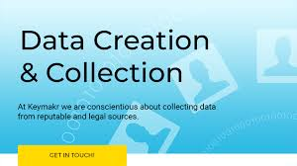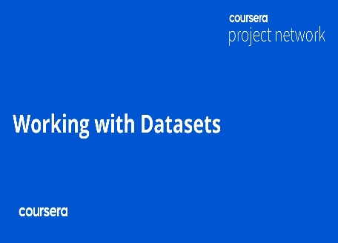**PROJECT FLOW DIAGRAM:**

